An Android Project on

Expense Tracker

“Avocado”

**Team Name**

Echo (Group 1)

**Team Members**

(Team Lead) Leonardo Otoni

Bernardo Sze

Joshua Dias

Kim Shiu Jeffrey Lo

**Project Overview**

The Avocado Expense App will enable users to record their everyday expenses in a categorized format based on custom categories/subcategories created by them or those preinstalled on the app. It is expected that through the recording of everyday purchases on this app, users would be able to budget themselves better and more efficiently.

Users will be required to record basic information about themselves on first use which will be later used by the app to create reports on how the user is doing on their expenses.

Users will also be able to set budgets for their expenses based on each subcategory they select. By setting a value and a time period for that subcategory, the user sets a budget and the app notifies them when they are about to cross that budget. The user may also be allowed to select when they get notified i.e 75% of budget crossed etc.

The app will power users with a dashboard that cross references information from the user and their recorded expenses to show simple yet powerful, easy to read graphics that would portray to the user their spending for the time period selected.

Avocado will be created using Android Studio on both Windows 10 and Mac machines. Java and SQLite will be used extensively. Slack will be used for team communication and trello for project management.

**Use Case Diagram**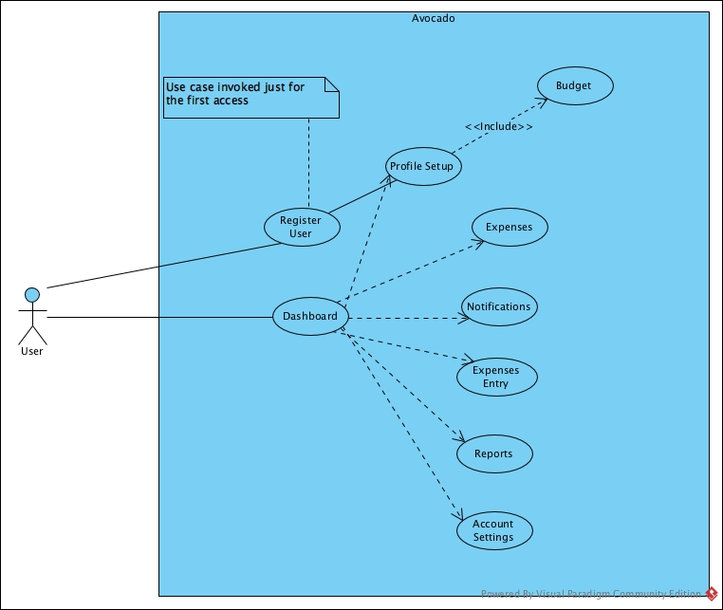

**Use Cases**

**Case 1: Register User**

The user would need to provide some personal information like name and email id.

**Case 2: Profile Setup**

The user can define custom categories for their expenses. For each category, they can provide a subcategory.

It is optional for the user to provide their annual income.

**Case 3: Dashboard**

The report would be a graphical representation of expenses for the month.

**Case 4: Expenses**

The app displays a list containing the details of all the expenses for the month.

**Case 5: Budget**

The page would lists out the current goals/budget.

The user can add additional goals/budget.

**Case 6: Notifications**

Once the user reaches a budget threshold or when they reach their budget, an alert is triggered. The threshold is set by the user.

**Case 7: Expenses Entry**

When the user is making an entry, they can set the nature of the expense. For example, they can set the date, location, and the category of the expense.

**Case 8: Reports**

Displays a list of details based on the user’s spending habits.

**Case 9: Account Settings**

It would provide option to view/change the current user profile.

**Project Design** 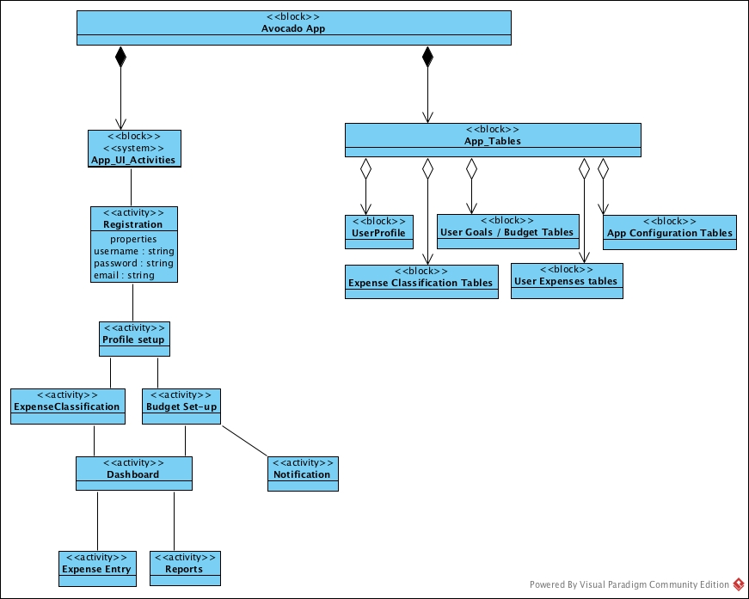

**Project Responsibilities**

**Leonardo Otoni** will be responsible for Case 3,6,7

**Bernardo Sze** will be responsible for Case 3,8,9

**Joshua Dias** will be responsible for Case 3,4,5

**Kim Shiu Jeffrey Lo** will be responsible for Case 1,2,3

**Class Diagram**